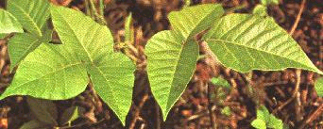
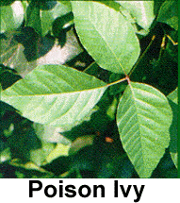
Eastern Poison Ivy; grows in sandy soil and in areas devastated by fire. It can be found throughout the eastern United States, as well as portions of the Midwest.

Rydber’s poison Ivy; can be found in parts of New England, in certain areas of the Mid-Atlantic states, and throughout most of the Rocky Mountain states. Rydberg's Poison Ivy grows as a small shrub about 3 feet high, with the characteristic three-leave formation on most plants, but this occasionally varies

Wester Poison Oak; grows as a thick bush or a climbing vine and can be found at almost any elevation from sea level to mountainous terrain up to 5,000 feet high. It is most prevalent in the far western United States.

Poison Ivy; can be found throughout most of the United States, except the far West. It grows as either an upright shrub or a climbing vine. In autumn, the leaves turn a dull red but are still poisonous

In the U.S., there are five different types of poison ivy, poison oak, and poison sumac. All the contain exact same substance that causes the blistering, itchy rash most of us get on contact with these plants. It’s called toxicodendrol, a sticky sap in the leaves and branches of the plants. If you’re sensitized (allergic) to this sap (and more than half of us are), the rash breaks out after about 12-72 hours, but only on areas which directly contacted the resin. This is called rhus dermatitis. The rash is usually red, raised, and often blistered at the central most areas. Because people usually brush by the plants, the rash may have a "streaky," linear, or patchy pattern, unlike stings which are usually single and round.
The rash spreads only by spread of the invisible sap on the skin, not by leaking blister fluid from the rash itself. That blister fluid is a product of your own body, and contains no poison ivy sap. The reason the rash often continues to break out in new areas beyond 72 hours is that people unknowingly continue to contact it --- from unwashed clothes (especially shoes and laces), sporting or gardening equipment, pets, etc. Anything that comes in contact with the plant can carry active sap for months! The sap is so potent, you can pass it from object to object a dozen times just by light contact, and the last object can still cause an intense rash. People leave an invisible "trail" of toxicodendrol where they sit, touch, sleep or bathe. They end up re-exposing themselves over a period of weeks. So don’t worry about your oozing blisters being contagious --- just start washing everything you may have touched!

Avoiding contact with the plant is the most important preventive measure. The site map below will help you recognize the different types of poison ivy/oak/sumac in your geographic area. If you’ve already come in contact with one of these, start washing everything --- soap, detergents and rubbing alcohol are all effective. This dramatically reduces the spread to yourself and others. In fact, if you wash with soap and water within 15 minutes after contact, you may not even get a rash.
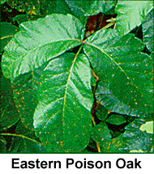
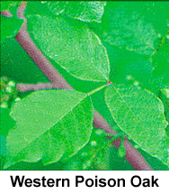
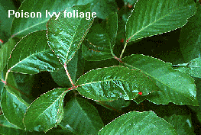
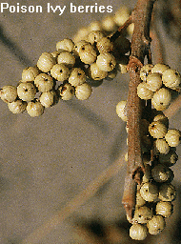
KNOW YOUR ENEMY! Watch out for this seemingly harmless little vine or shrub in the woods. Note the three-part leaves with jagged edges...
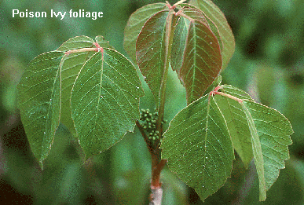
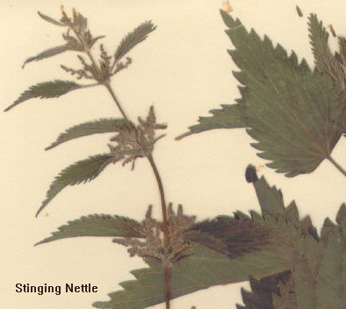
Notice also the colour and configuration of Poison Ivy berries...
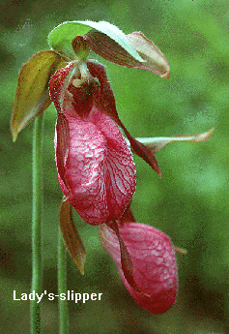
LADY'S SLIPPER ORCHIDS also cause an uncomfortable skin irritation when theyare handled, especially if the leaves & stems are wet- good reason to avoid picking the flowers!Of course, it's always better to leave wildflowers for everyone to enjoy, anyway.

Stinging Nettles (Genus Urtica) also cause skin irritation, though not asseriously as Poison Ivy; in fact the discomfort may persist only a few minutes.Nettles are armed with tiny hairs on the stems and leaves, which are razor-sharp andinject the irritant, formic acid, when the ends break off on contact. These herbs, whosefibres were once woven into cloth, twine and nets (hence the name), are common in waste land,roadsides, and behind beaches in Nova Scotia.

Poison Sumac; can be found mainly in the eastern United States. It grows in peat bogs and swamps. To identify Poison Sumac, look for the fruit that grows between the leaf and the branch. Nonpoisonous sumac has fruit growing from the ends of it's branches.

Poison-oak is usually a shrub, though it sometimes becomes a vine several inches in diameter that grows high into the oak trees attached by air-roots. The leaves DO come in threes. They are shiney, without prickers, and the middle leaf has a distinct stalk.
It is harder to identify Poison Oak in the winter, when it loses its leaves and looks like erect bare sticks coming from the ground.

Poison Oak is highly variable. It varies from shrub to vine. The leaves vary from red to green. It has erect stems, leaves in threes, small greenish flowers, and smooth seeds that are about 1/4 inch across. It is often lush in coastal canyons, but sparse in the mountain woodland. It is deciduous, and often looses its leaves in late summer, leaving it hard to recognize. The erect branches give a clue.
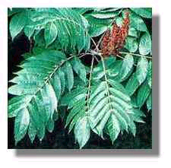
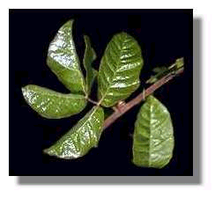

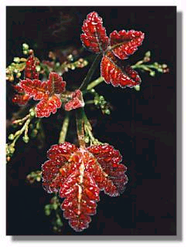
Poison Sumac Poison Oak, Pictures

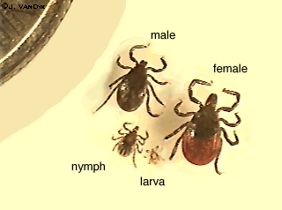
TICKS with a Dime comparison
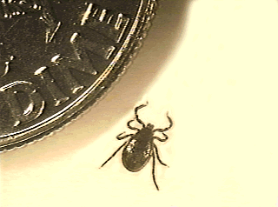

TRIX® is a very effective remover which easily and safely can remove the whole tick, big or small. Even the smallest tick nymph is easy to remove with this tool.

Press down the loop and put it over the tick, as close to the skin as possible.

Let go of the button and tilt the tick remover perpendicularly against the skin.

Keep the green point against the skin and turn it one round between your fingers.

Lift away the tick. Wash the bite area.

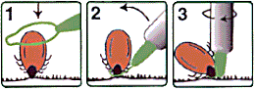

If it is a very small tick: Place the green point close to the tick and press the point down a little into the skin. Release the button, twist and lift away.

TWIST THE TICK AWAY, DO NOT PULL

Mouthparts of Tick

If you look at the photomicrograph of the ticks sting- and suction organ (hypostome) you can easily see that if you pull straight out the barbs grip and get even more stuck in the skin (that´s what barbs are for). The risk of pulling the tick apart increases.

If you twist instead the barbs will release their grip easier and all of the front part together with the head can come along. Tests have shown that it does not matter what direction you twist, clockwise or counterclockwise gives the same good results.

TWISTING ALSO REDUCES PAIN

When you pull a tick away, it causes some pain in the skin which may cause some pets to really dislike the treatment. But if you twist it away with a tickremover which keeps the mouthpart in a firm grip, the removal will be painless and the pet usually do not even notice because the bite area is stunned by the tick.
Always twist the tick away!
It is faster. Gives less pain. Safer complete removal of whole tick. Decreases the risk of infections.

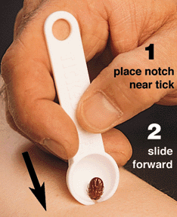
Why remover?
If you grab hold with your fingers on the body of the tick, or use tweezers or tweeze like tools, there is a risk of pressing contagious substances into the bite wound. Then it is better to use a modern remover which eliminates this and also decreases the risk to adopt a disease or just a plain infection.
Ideas for removal tools

Removing a tick
When you find a tick, use tweezers to pick up the body and pull s-l-o-w-l-y and gently, and the mouthparts will release. You should see a small crator in your dog's skin, if you see what looks like black lines, you've left the head of the tick in. At this point, if your dog is mellow enough, you should try and pick it out. Otherwise, you may need to take your pet into the vet, as the head parts will lead to an infection. Ticks carry a lot of rickettsial diseases, including Lyme disease and Rocky Mountain Spotted Fever, so you should wash your hands thoroughly with soap after handling a tick.
Some veterinarians will put on gloves, smear one finger with a bit of mineral oil and massage the protruding part of the tick for a minute or so. The tick will back out.
Tips:
- Don't use any of the folklore remedies (matches, cigarettes, pins, gasoline) that will irritate the tick. They increase the likelihood that the tick will "spit up" in you, which increases the risk of disease.
- Oil is not effective because the breathing requirements of the tick are so small it could last hours covered with oil.
- The mouthpiece is barbed rather than spiralled, so trying to rotate the tick out doesn't provide any advantage.
- The preferred method is to use special tweezers designed for that purpose, and pull straight out.
Lyme disease (see below) is usually carried by tiny deer ticks (two other kinds of ticks have also been identified as carriers) , which are the size of the head of a pin. You must look yourself or your pet over very carefully to find these kind of ticks. Other ticks can be as large as peppercorns. This can vary depending on whether or not the tick has yet engorged itself -- the deer tick can be as large as the more familiar Dog Tick if it has had time to feed. So if you are in doubt, preserve the tick in rubbing alcohol and have your vet take a look at it.

Infections or abscesses
If you have left the head of the tick in your pet's skin, chances are there will be an infection or an abscess in a week or so. Try disinfecting the area thoroughly with 70% alcohol (it takes about 5 minutes for alcohol to sterilize an area). Ethyl alcohol is less toxic than rubbing alcohol; vodka or any high-proof liquor will work, but good commercial antiseptic cleansers are recommended. Then apply a combination antibiotic ointment. If an infection occurs anyway, take your pet in to the vet to have it drained.

Disposing of ticks
To dispose of the tick, drop it into alcohol to kill it, then dispose of it. Flushing them down the toilet WILL NOT KILL THEM. Squishing them with a thumbnail is not recommended, and is not easy anyway. You might save the tick in a jar of alcohol for identification, to help decide whether possible infection has occurred.

